Bridging Rental Assistance Program (BRAP)
Monitoring Report
Quarter 3 FY2015 (January, February, March 2015)

The Bridging Rental Assistance Program (BRAP) has been established in recognition that recovery can only begin in a safe, healthy, and decent environment, a place one can call home. The Office of Substance Abuse and Adult Mental Health Services recognizes the necessity for rental assistance for persons with mental illness, particularly those being discharged from hospitals, group homes, homeless shelters,and places considered substandard for human habitation. There is not a single housing market in the country where a person receiving Social Security as his or her sole income source can afford to rent even a modest one-bedroom apartment. According to a report issued by the Technical Assistance Collaborative, Priced out in 2012 in Maine, 95% of a person’s SSI standard monthly payment is needed to pay for the average one-bedroom apartment statewide. In Cumberland County the amount is 94% and Sagadahoc 98%. In the City of Portland 115% of a person’s SSI is necessary to pay for the average one-bedroom apartment and in the KEYS area (Kittery, Elliot, York and South Berwick) 110%.
BRAP is designed to assist individuals who have a psychiatric disability with housing costs for up to 24 months or until the individuals are awarded a Housing Choice Voucher (aka Section 8 Voucher), another federal subsidy, or until the individuals have an alternative housing placement. All units subsidized by BRAP funding must meet the U.S. Department of Housing and Urban Development’s Housing Quality Standards and Fair Market Rents. Following a Housing First model, initial BRAP recipients are encouraged, but not required to accept the provision of services to go hand in hand with the voucher.
The monitoring of the Bridging Rental Assistance Program (BRAP) is the responsibility of the Office of Substance Abuse and Adult Mental Health Services (SAMHS) and particularly the Data, Quality Management, and Resource Development team.

The bullets below highlight some of the details regarding persons who are currently waiting for a BRAP voucher: The percentage terms reflect the percentage of relative change compared to the last report.

- Priority #1 applicants (Discharge from a psychiatric hospital within the last 6 months). Riverview and Dorothea Dix consumers are typically not waiting more than 3 business days from the date of a completed application. Statewide priority 1 vouchers decreased from 17 to 0.
- Priority #2 applicants (Homeless) have decreased from 227 to 58 persons.
- Priority #3 applicants (Substandard Housing) have decreased from 4 to 0 persons.
- Priority #4 applicants (Community Residential Facility) decreased from 17 to 4 persons.
- Persons on the waitlist greater than 90 days have substantially decreased from 188 persons to 45 persons—over the next quarter, state staff will attempt contact with these persons to confirm their whereabouts and determine their continued desire to remain on the waitlist.

Since inception of the wait list, there has been a total of 3,098 BRAP vouchers awarded broken down as follows: Priority #1, 1,450; Priority #2, 1,318; Priority #3, 40; Priority #4, 269. Note that 21 vouchers have been awarded to persons with no priority. In the last quarter 106 vouchers were awarded.

The BRAP census as of December 31, 2014 is 756 vouchers with an additional 165 persons looking.

The overall BRAP budget for FY 15 is now a part of the baseline budget at SAMHS and remains at $5,372,414.00. Depending on regional demand for vouchers, we anticipate the census being able to support between 930 to 975 vouchers at any given time statewide.

The number of persons on the program for greater than 24 months remains steady at 50% of the entire program. This is principally a result of decades of federal and state cuts to low-income and supportive housing programs, including persons who will not qualify for Section 8 due to criminal history. The lack of availability of these resources, particularly Section 8 at the federal level, has translated to increased pressures on state programs such as BRAP.

SAMHS administers a substantial number of Shelter Plus Care vouchers, more than any other state on a per-capita basis. The census as of December 31, 2014 is 1,043 vouchers. This program is funded by the U.S. Department of Housing and Urban Development and has seen significant growth over the last decade, the result of SAMHS aggressively applying for and receiving new grants each year. Despite reductions in overall HUD funding, the City of Portland requested that DHHS submit a new Shelter Plus Care application that, if funded, will provide housing and supports for 17 Chronically homeless persons in Portland.

BRAP Waitlist Status--Graph:
Detail by Priority Status to include those persons waiting longer than 90 Days
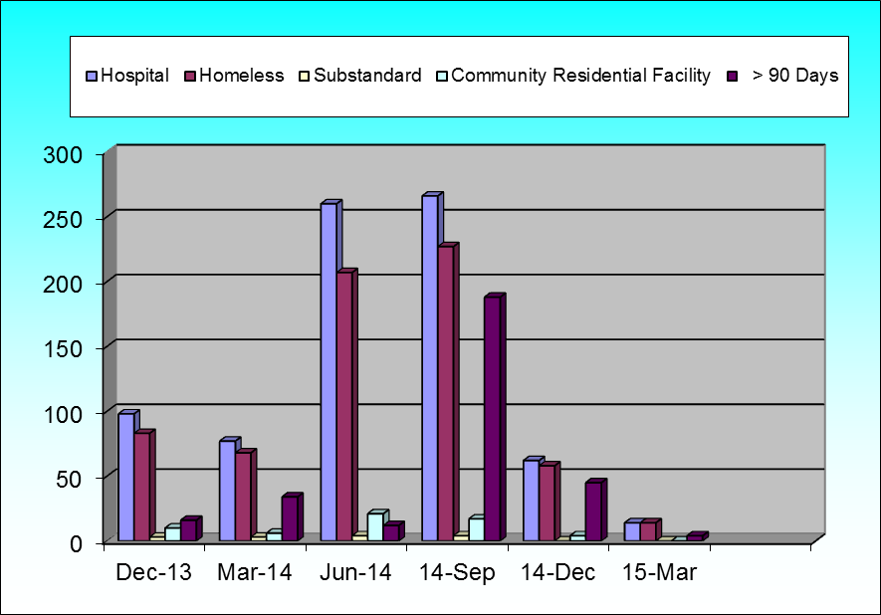

BRAP Waitlist Status—Table:
Detail by Priority Status to include those persons waiting longer than 90 Days
Reporting Period | Dec-13 | Mar-14 | Jun-14 | 14-Sep | 14-Dec | 15-Mar |  | % Change relative to Last Report
Total number of persons waiting for BRAP | 98 | 77 | 260 | 266 | 62 | 14 |  | -77%
Priority 1—Discharge from state or private psychiatric hospital within last 6 months | 2 | 0 | 26 | 17 | 0 | 0 |  | 0%
Priority 2—Homeless (HUD Transitional Definition) | 83 | 68 | 207 | 227 | 58 | 14 |  | -76%
Priority 3—Sub-standard Housing | 3 | 3 | 4 | 4 | 0 | 0 |  | 0%
Priority 4—Leaving a Community Residential living facility | 10 | 6 | 21 | 17 | 4 | 0 |  | -100%
Total number of persons on wait list more than 90 days awaiting voucher | 16 | 34 | 12 | 188 | 45 | 4 |  | -91%

BRAP Awards—Graph
Cumulative Since Inception of Waitlist
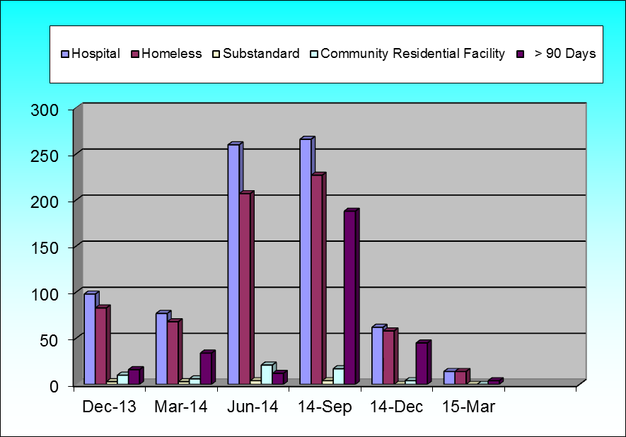

BRAP Awards—Table
Cumulative Since Inception of Waitlist
Reporting Period | Dec-13 | Mar-14 | Jun-14 | 14-Sep | 14-Dec | 15-Mar |  | % Change relative to Last Report
Total number of persons waiting for BRAP | 98 | 77 | 260 | 266 | 62 | 14 |  | -77%
Priority 1—Discharge from state or private psychiatric hospital within last 6 months | 2 | 0 | 26 | 17 | 0 | 0 |  | 0%
Priority 2—Homeless (HUD Transitional Definition) | 83 | 68 | 207 | 227 | 58 | 14 |  | -76%
Priority 3—Sub-standard Housing | 3 | 3 | 4 | 4 | 0 | 0 |  | 0%
Priority 4—Leaving a Community Residential living facility | 10 | 6 | 21 | 17 | 4 | 0 |  | -100%
Total number of persons on wait list more than 90 days awaiting voucher | 16 | 34 | 12 | 188 | 45 | 4 |  | -91%

*Note: 21 persons awarded with no priority

